Metrics

Why Metrics Server is needed?
- Because Kubernetes by default doesn’t know how much CPU or memory your pods are using.
- Metrics Server collects this info and provides it to Kubernetes.
Uses of Metrics.
Metrics in Kubernetes are used to monitor real-time CPU, memory, and resource usage so the system can make scaling, scheduling, and health decisions
Check the nodes are Ready in status:
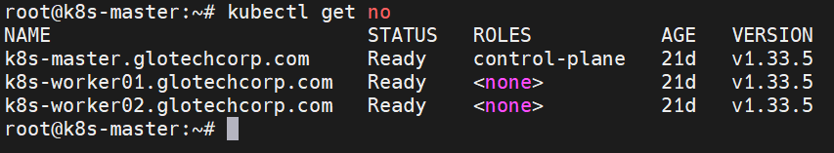

Then we check the usage of CPU and Memory:


It will shown the metrics api is not available, we want to install the metrics application. It is link to download the api applications,

kubectl apply -f https://github.com/kubernetes-sigs/metrics-server/releases/latest/download/components.yaml

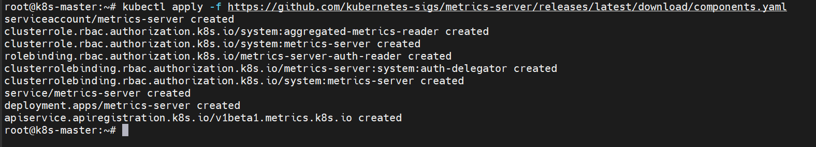

Some contents are modified in configuration after the application was downloaded.
kubectl -n kube-system edit deployment.apps metrics-server


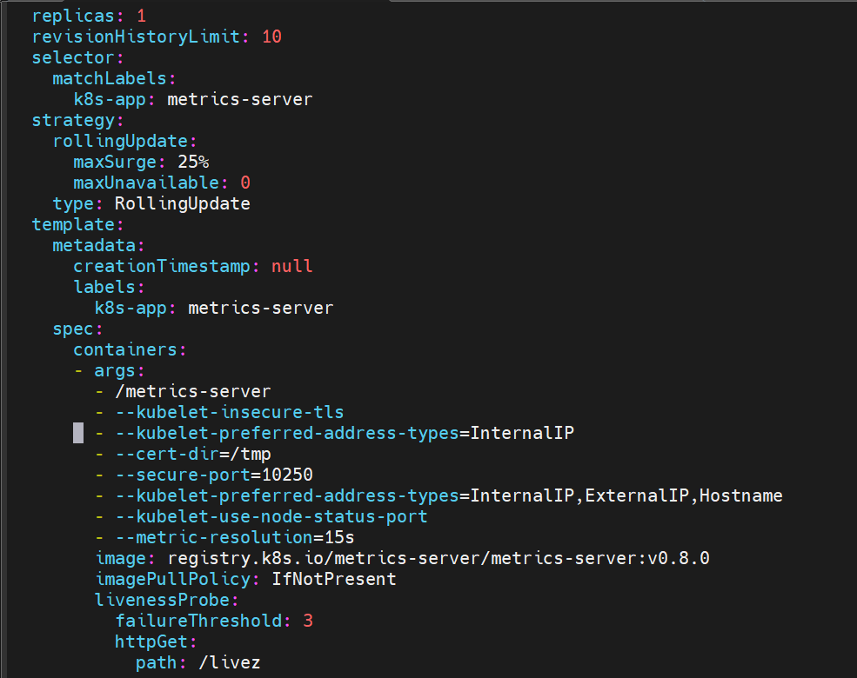

/metrics-server - This is the main executable for the Metrics Server container.

--kubelet-insecure-tls - This tells Metrics Server to skip TLS certificate verification when connecting to kubelets.
Used in clusters where kubelets use self-signed certificates or don’t have proper CA setup.

--kubelet-preferred-address-types=InternalIP
This tells Metrics Server which IP type to use when talking to kubelets.

After dowload the metrics server,to go and check the top of the node.

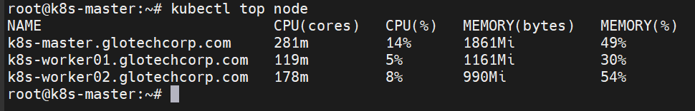

Check the top of the pod:
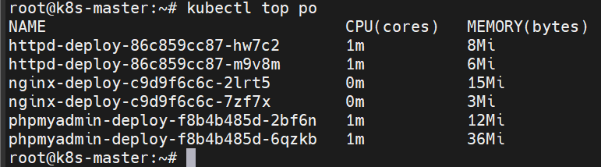

To find the number of CPU :
#nproc
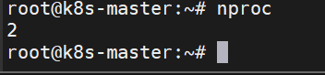

To find memory usage:
#free -h
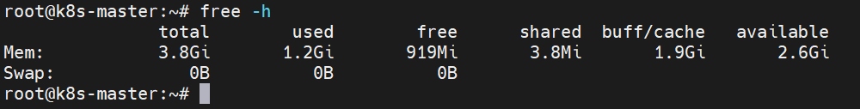

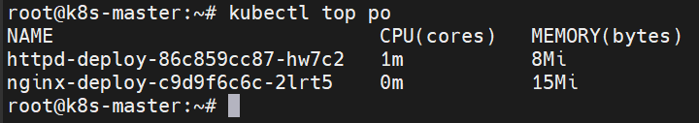

#dd if=/dev/zero of=/dev/null &

dd → a tool to copy data from one place to another.

if=/dev/zero → input file is /dev/zero (produces endless zeros).

of=/dev/null → output is discarded (a black hole).

& → run the command in the background.

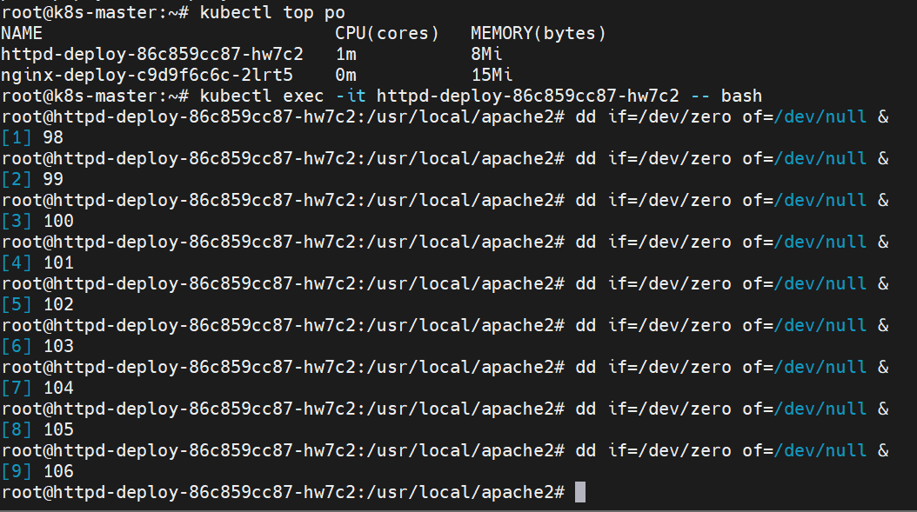

Now we can check the cpu usage, it will take nearly 2 cpu count
1 CPU = 1000m 0.5 CPU = 500m 0.1 CPU = 100m

Once pod reached the CPU consumed totally and is deleted old pod and create the new pod.

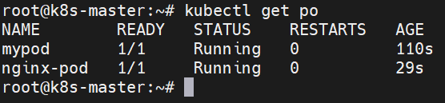

Create yaml file for pod limitation.
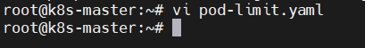

we can set the limitation of the cpu to consuming the space for the particular pod.

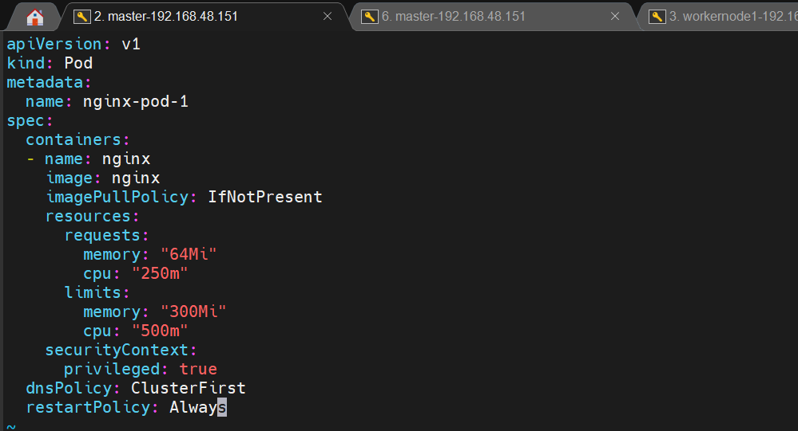

Create and login into the pod the run the background process. And the check the cpu consuming process of the pod.

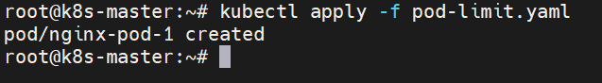

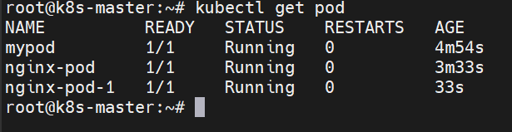

And open the duplicate session and check the cpu consuming process.
